## PIXEL PILOT – DESIGN AUTOMATION BOT

**A PROJECT REPORT**

***Submitted by***

|  |  |
| --- | --- |
| **SHARUKESHWAR P** | **220701265** |

***in partial fulfillment of the course***

**OAI1903 - INTRODUCTION TO ROBOTIC PROCESS AUTOMATION**

***for the degree of***

**BACHELOR OF ENGINEERING**

***in***

**COMPUTER SCIENCE AND ENGINEERING**



**RAJALAKSHMI ENGINEERING COLLEGE**

**RAJALAKSHMI NAGAR**

**THANDALAM**

**CHENNAI – 602 105**

**NOVEMBER 2024**

**RAJALAKSHMI ENGINEERING COLLEGE**

**CHENNAI - 602105**

**BONAFIDE CERTIFICATE**

Certified that this project report **“PIXEL PILOT - DESIGN AUTOMATION BOT”** is the bonafide work of **“SHARUKESHWAR P (220701265)”** who carried out the project work for the subject OAI1903-Introduction to Robotic Process Automation under my supervision.

|  |  |
| --- | --- |
|  | **Ms. U.Farjana, M.Tech.**  **SUPERVISOR**  Assistant Professor  Department of Computer Science and Engineering  Rajalakshmi Engineering College  Rajalakshmi Nagar  Thandalam  Chennai - 602105 |

Submitted to Project and Viva Voce Examination for the subject OAI1903-Introduction to Robotic Process Automation held on __________.

**INTERNAL EXAMINER EXTERNAL EXAMINER**

**ACKNOWLEDGEMENT**

Initially, we thank the Almighty for being with us through every walk of our life and showering his blessings through the endeavor to put forth this report. Our sincere thanks to our Chairman **Thiru. S.Meganathan, B.E., F.I.E.,** our Vice Chairman **Mr. M.Abhay Shankar, B.E., M.S.,** and our respected Chairperson **Dr. (Mrs.) Thangam Meganathan, M.A., M.Phil., Ph.D.,** for providing us with the requisite infrastructure and sincere endeavoring to educate us in their premier institution.

Our sincere thanks to **Dr. S.N.Murugesan, M.E., Ph.D.,** our beloved Principal for his kind support and facilities provided to complete our work in time. We express our sincere thanks to **Dr. P. Kumar, M.E., Ph.D.,** Professor and Head of the Department of Computer Science and Engineering for his guidance and encouragement throughout the project work. **Ms. U.Farjana, M.Tech.,** Assistant Professor**,** Department of Computer Science and Engineering for their valuable guidance throughout the course of the project. We are very glad to thank our Project Coordinators,Professor, **Dr. N.Durai Murugan, M.E., Ph.D.,** Associate Professor, and **Mr. B.Bhuvaneswaran, M.E.,** Assistant Professor (SG), Department of Computer Science and Engineering for their useful tips during our review to build our project.

**SHARUKESHWAR P (220701265)**

**ABSTRACT**

In today's fast-paced digital world, designing has become an essential yet time-consuming task. From creating visually appealing templates to ensuring consistency across various platforms, designers often find themselves burdened with repetitive processes that stifle creativity. This inefficiency not only delays project timelines but also detracts from the core focus of imaginative and meaningful design work.

Enter **Pixel Pilot**, an intelligent automation bot designed to redefine the way we approach digital design. Aimed at empowering designers and creative professionals, Pixel Pilot bridges the gap between creativity and efficiency by automating repetitive design tasks. It enables users to focus on ideation and storytelling while the bot handles routine processes.

This project envisions a future where designers are liberated from mundane tasks, fostering a workspace that prioritizes ingenuity and originality. By integrating intelligent automation, Pixel Pilot aspires to become an indispensable assistant that evolves with user needs. With its capability to automate and streamline workflows today, and the promise of advanced AI-driven customization in the near future, Pixel Pilot represents a step toward a more inspired and efficient design ecosystem.

As technology advances, Pixel Pilot aims to not just support designers but to inspire them, becoming a trusted co-creator in their artistic journey.

**TABLE OF CONTENTS**

**CHAPTER NO. TITLE PAGE NO.**

**ABSTRACT iii**

**LIST OF FIGURES v**

**LIST OF ABBREVIATIONS vi**

**1. INTRODUCTION 1**

1.1 BACKGROUND 1

1.2 PROBLEM STATEMENT 1

1.3 PROJECT OBJECTIVES 1

1.4 SCOPE OF THE PROJECT 2

1.5 LIMITATIONS 2

**2. LITERATURE REVIEW 3**

2.1 GENERAL 3

2.2 STATE OF THE ART TECHNIQUES 3

**3. SYSTEM DESIGN 5**

3.1 SYSTEM FLOW DIAGRAM 5

3.2 ARCHITECTURE DIAGRAM 6

3.3 SOFTWARE AND HARDWARE 7

REQUIREMENTS

**4. PROJECT DESCRIPTION 9**

4.1 METHODOLOGIES 9

**5. IMPLEMENTATION AND RESULT 12**

5.1 IMPLEMENTATION PROCEDURE 12

5.2 OUTPUT 14

5.3 RESULT AND ANALYSIS 19

**6. CONCLUSION AND FUTURE ENHANCEMENTS 21**

6.1 CONCLUSION 21

6.2 FUTURE ENHANCEMENTS 22

**REFERENCES 23**

**LIST OF FIGURES**

|  |  |  |
| --- | --- | --- |
| **FIGURE NO.** | **FIGURE NAME** | **PAGE NO.** |
| 3.1 | SYSTEM FLOW DESIGN | 5 |
| 3.2 | ARCHITECTURE DIAGRAM | 6 |
| 5.1 | STUDIO WORKFLOW | 14 |
| 5.2 | CANVA TEMPLATE - INITIAL DESIGN | 17 |
| 5.3 | SAMPLE INPUT 1 | 18 |
| 5.4 | SAMPLE INPUT 2 | 18 |
| 5.5 | SAMPLE INPUT 3 | 18 |
| 5.6 | SAMPLE INPUT 4 | 18 |
| 5.7 | SAMPLE OUTPUT - FINAL DESIGN | 19 |

**LIST OF ABBREVIATIONS**

|  |  |
| --- | --- |
| **ABBREVIATION** | **ACRONYM** |
| B.E. | Bachelor of Engineering |
| M.Tech. | Master of Technology |
| Ph.D. | Doctor of Philosophy |
| RPA | Robotic Process Automation |
| UI | User Interface |
| UX | User Experience |
| CV | Computer Vision |
| AI | Artificial Intelligence |
| OCR | Optical Character Recognition |
| DOM | Document Object Model |

## CHAPTER 1

## INTRODUCTION

**1.1 BACKGROUND**

In today's visually-driven world, design is key to communication and branding. Platforms like Canva simplify professional visual creation, but repetitive tasks like template updates and ensuring uniformity hinder creativity. Pixel Pilot addresses this by automating such processes, freeing designers to focus on innovation and their creative vision.

**1.2 PROBLEM STATEMENT**

Designers often face challenges in balancing creativity with efficiency. Tasks such as updating template content, maintaining consistency, and adapting designs for multiple use cases demand significant manual effort, leading to decreased productivity and potential burnout. Moreover, the lack of automation tools specifically tailored for creative professionals results in unnecessary delays and errors in high-volume design workflows.

**1.3 PROJECT OBJECTIVES**

This project seeks to address these issues by introducing a bot that streamlines design processes, thereby enabling faster, error-free outputs. The specific objectives include:

1. **UI Automation :** Identify and streamline repetitive design tasks in Canva, such as text extraction, duplication, and template updates, to improve efficiency and accuracy.
2. **Data Extraction :** Develop a system to extract key design elements (e.g., text, shapes, and images) from Canva templates for further processing and automation.
3. **Design Customization :** Implement a module that allows users to modify design properties, such as text styles, colors, and layout, offering flexibility to achieve tailored outputs based on specific requirements.
4. **AI-Driven Replication :** Integrating AI models that enable the bot to replicate and adapt designs based on a dataset, making automation more intuitive, human-like, and capable of generating creative outputs aligned with user preferences, in future iterations.

**1.4 SCOPE OF THE PROJECT**

This project is focused on automating repetitive processes within Canva’s interface, such as extracting and replicating text and simple visual adjustments. While the current implementation emphasizes task automation, the project envisions incorporating advanced AI-driven capabilities for adaptive design in the future ultimately evolving into a creative assistant.

**1.5 LIMITATIONS**

While this project aims to streamline design workflows with Pixel Pilot, there are certain limitations to consider :

* **Predefined Actions :** The current prototype relies on predefined workflows and lacks adaptability to complex, non-standard design tasks.
* **Creative Judgement :** Tasks requiring aesthetic or creative decision-making are beyond the capabilities of this iteration.
* **AI Integration :** While future versions aim to incorporate AI for adaptive design, the current system does not include these capabilities.
* **Platform Dependency :** The automation depends heavily on Canva’s existing UI, making it susceptible to disruptions from interface updates.

By addressing these limitations and continuously improving the system, we aim to enhance its accuracy and robustness.

**CHAPTER 2**

## LITERATURE REVIEW

### **2.1 GENERAL**

Early approaches to design automation primarily focused on basic template-driven tools and macros, which allowed for repetitive tasks to be performed with minimal user input. These methods, while efficient for simple tasks, lacked flexibility and adaptability for dynamic workflows. The limitations of such tools became evident as design demands grew more complex, requiring a balance between creativity and efficiency. Traditional automation struggled with contextual nuances, user-specific preferences, and the ability to manage creative elements seamlessly across diverse projects.

### **2.2 STATE OF THE ART TECHNIQUES**

Recent advancements in automation, artificial intelligence, and user experience have paved the way for more sophisticated tools that address modern design challenges. These innovations aim to combine technical precision with creative flexibility, offering solutions that align with the evolving needs of designers.

* **Computer Vision :** CV techniques are pivotal in automating the recognition and manipulation of visual elements in design software. By analyzing images and identifying patterns, CV can efficiently extract relevant design features like text, shapes, and layout properties from templates, facilitating further automation and customization.
* **DOM Manipulation :** This allows automation systems to interact with and modify elements of a webpage or design interface in real-time. By directly accessing and editing HTML elements, it enables precise control over the design structure, allowing for the seamless updating and customization of content.
* **Artificial Intelligence** : AI-powered systems bring adaptability and human-like intuition to design automation. Machine learning algorithms can analyze design elements, predict user preferences, and assist in creative decision-making.
* **Optical Character Recognition** : OCR technology enables accurate text recognition from images and templates, aiding in data extraction and dynamic content management within designs.
* **Semantic Style Transfer :** Using advanced deep learning techniques, the system could replicate specific design aesthetics from reference images or templates, applying them to new projects while preserving user-defined content.

## Despite these advancements, challenges remain. Current systems face limitations in managing real-time user customizations, adapting to complex creative workflows, and handling dynamic platform updates. Future improvements must focus on integrating these state-of-the-art techniques to bridge existing gaps and deliver a seamless, intuitive user experience.

## While significant progress has been made in design automation, future research and development must address the limitations of existing technologies. Priorities include enabling bots to handle nuanced creative tasks, incorporating user-specific customization, and improving adaptability to platform changes. Advanced AI models capable of learning from limited datasets and replicating complex design workflows are essential to achieving this vision. By overcoming these challenges and leveraging cutting-edge technologies, we can transform design automation into a powerful tool that enhances creativity, efficiency, and user satisfaction.

## 

## 

## CHAPTER 3

## SYSTEM DESIGN

### **3.1 SYSTEM FLOW DIAGRAM**

### E:\Downloads1\Pixel Pilot.pngPixel Pilot

**FIG 3.1** SYSTEM FLOW DIAGRAM

### 

### 

### **3.2 ARCHITECTURE DIAGRAM**

### E:\Downloads1\arch pp.jpgarch pp

**FIG 3.2** ARCHITECTURAL DIAGRAM

**Overview**

The design automation bot is a straightforward approach built using Uipath tools. It involves the following steps:

1. **User Input and Template Selection :** The user uploads a signature image to the workflow. Designers choose a design template or upload projects for automation.
2. **UI Element Indication and Detection :** The bot identifies and maps placeholders and anchor UI elements using Computer Vision and DOM Manipulation.
3. **Input Customization and Replacement :**  Users provide inputs (e.g., text, fonts, colors, images), which are systematically applied to placeholders.
4. **Automation and Execution :**  The bot replaces placeholders, applies formatting, and completes the automation process.
5. **Error Handling and Feedback Loop :** Errors are detected, and users are notified for corrections through an interactive feedback mechanism.
6. **Output Generation :** The final design is generated, allowing users to review, save, and export the completed work.

### **3.3 SOFTWARE AND HARDWARE REQUIREMENTS**

**Software**

* **UiPath Studio :** To build the automation workflow.
* **UiPath Computer Vision :** For automating the identification and interaction with UI elements in graphical designs.
* **Access to Canva account :** Required for accessing and automating design workflows on the Canva platform.

**Hardware**

* **Standard Computer:** A computer with enough processing power and memory is sufficient.
* **Network :** Since Canva and other web platforms will be involved in automation, a stable and fast internet connection is crucial for accessing templates, uploading designs, and interacting with cloud services.

## 

## CHAPTER 4

## PROJECT DESCRIPTION

## **4.1 METHODOLOGIES**

**Data Collection**

* **Template Designs :** Collect design templates from platforms like Canva to serve as the base for automation. These templates include text boxes, shapes, and visual elements commonly used in design workflows.
* **Platform Interaction Data :** Observe and record user interactions with design elements (e.g., text edits, resizing, and alignment changes) to simulate real-world scenarios.
* **Customization Preferences :** Gather data from user inputs specifying design preferences like font styles, color schemes, and layouts for implementing personalization features.

**Choosing UiPath CV Model :**

* **Computer Vision Model Selection :** Utilize UiPath's Computer Vision activities to identify and interact with design elements in web-based platforms. These models allow automation to recognize on-screen components, even with varying resolutions and layouts.
* **Accuracy in Element Detection :** The chosen model should excel in detecting dynamic UI elements like text fields, images, and buttons for efficient automation.

**Target and Anchor Identifications :**

* **Target Elements :** Define primary targets (e.g., text boxes, images, shapes) to automate actions like editing, updating, or rearranging.
* **Anchor Points :** Use static reference points, such as headers, footers, or specific UI components, to ensure consistent identification of targets across different templates and layouts.

**User Inputs :**

* **Dynamic Inputs :** Allow users to specify design modifications, such as text updates, font changes, or resizing instructions.
* **Interactive Features :** Enable users to preview changes and provide feedback during the automation process to ensure alignment with their creative goals.

**Workflow Development :**

* **Template Scanning :** Use computer vision and DOM manipulation to identify and extract design components, including text, shapes, and images.
* **Component Mapping :** Store extracted elements in structured formats like data tables for easy manipulation.
* **Custom Design Implementation :** Automate the modification of templates based on user-provided inputs, ensuring alignment with creative goals.
* **Web Automation:** Seamlessly integrate with platforms like Canva through browser-based automation for template editing and updates.

**Design Customization Module :**

* **Property Adjustments :** Automate changes to properties like font size, color, alignment, and spacing.
* **Template Personalization :** Adapt designs based on user preferences or brand guidelines, such as inserting logos or applying predefined color schemes.

### Integration of Advanced Techniques :

* **DOM Manipulation :** Scrape and interpret HTML structures of web templates to access and manipulate design elements programmatically.
* **OCR for Text Recognition :** Use Optical Character Recognition to extract text from embedded graphics or inaccessible design layers.

### Error Handling and Validation :

* **Error Detection :** Implement validation checks to ensure the automation executes accurately without disrupting the original design layout.
* **Recovery Mechanisms :** Define fallback actions to address unexpected changes in the UI, such as dynamic element repositioning.
* **Iterative Improvement:** Continuously monitor the bot’s performance and make necessary adjustments to improve accuracy and efficiency, especially when the UI updates.

## CHAPTER 5

## IMPLEMENTATION AND RESULTS

### **5.1 IMPLEMENTATION PROCEDURE (Using UiPath Studio)**

* **Create a New Workflow:** Begin by creating a new workflow in UiPath Studio to define the structure of Pixel Pilot's automation process.
* **Add Activities:**
  + **Initiate Process :**
    1. Use a **Sequence** activity to organize the process flow.
    2. Add **Input Dialog** activities to allow the user to define parameters like target template and input design elements
  + **UI Interaction :**

1. **Click :** Automate selection of design elements such as text boxes or shapes.
2. **Type Into :** Update text in preselected design elements.
3. **Get Text :** Extract content from existing design elements for logging or modification.
4. **Find Element :** Ensure precision by locking onto specific UI components before executing actions. This will encapsulated by an **Anchor Base** activity.
   * **Data Handling :**
5. Store extracted or updated data in variables or collections for further use.
   * **Error Handling :**
6. Include **Try Catch** blocks to manage unexpected UI changes or errors

gracefully.

* + **Connect Activities :**

1. Use logical connectors to sequence activities for a smooth execution flow.
   * **Output Results :**
2. Save logs or extracted data to a file for review.
3. Display real-time updates to the user via **Message Box** or Output Panel.
4. Download the designs and organize them in a folder.
   * **Test and Debug :**
5. Test the workflow across multiple templates to verify adaptability and accuracy. Use **Log Message** activities to keep track of the workflow analogous to console.log() statements.
6. Debug issues like inconsistent element identification or timing errors. Use **Delay** activityand set it to 2 seconds, between other activities to account for slow internet or delay in identifiying elements.

## 

## 

## 5.2 OUTPUT

* **Studio Workflow :**

i.

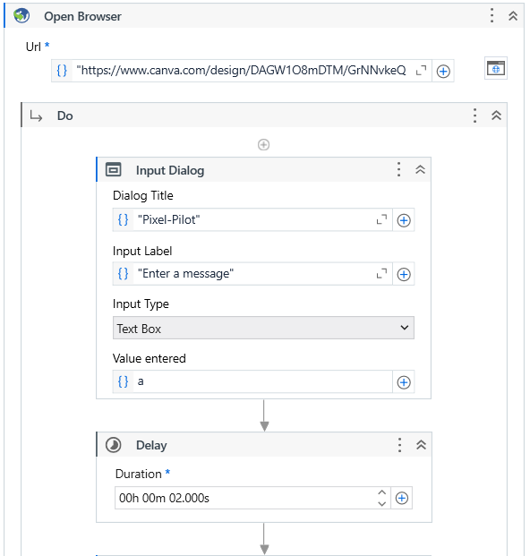

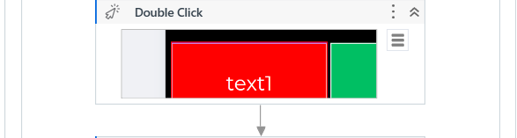

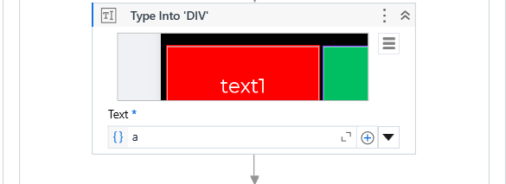

ii. iv.

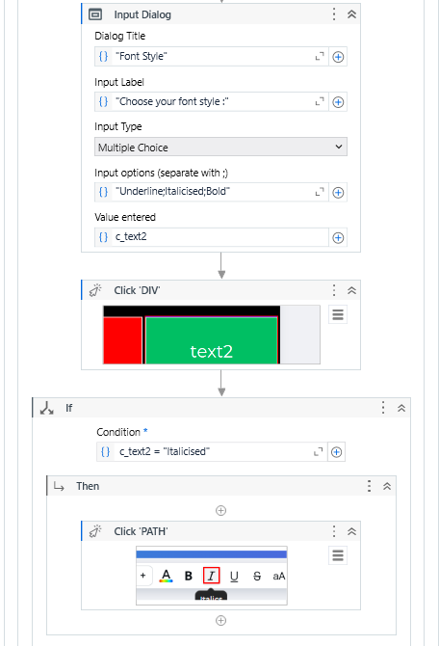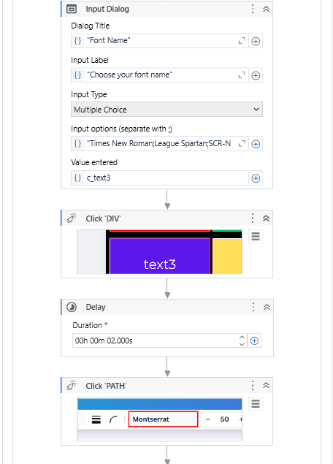

iii. v.

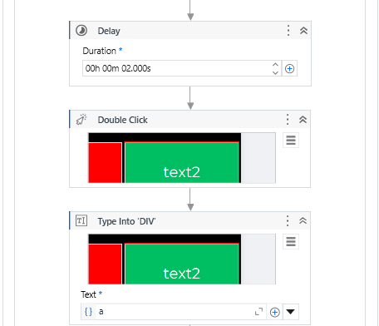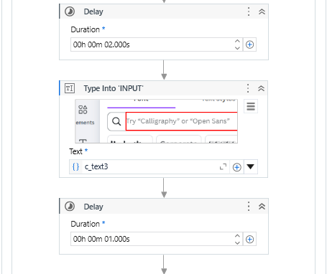

vi. viii.

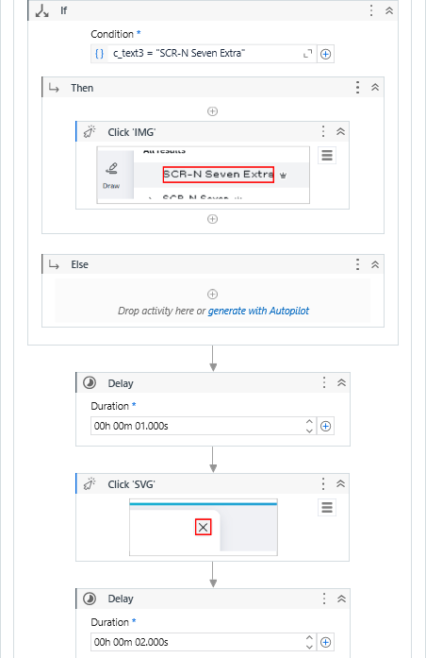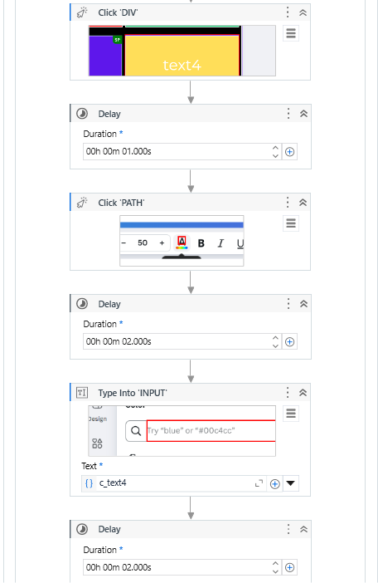

vii. ix.

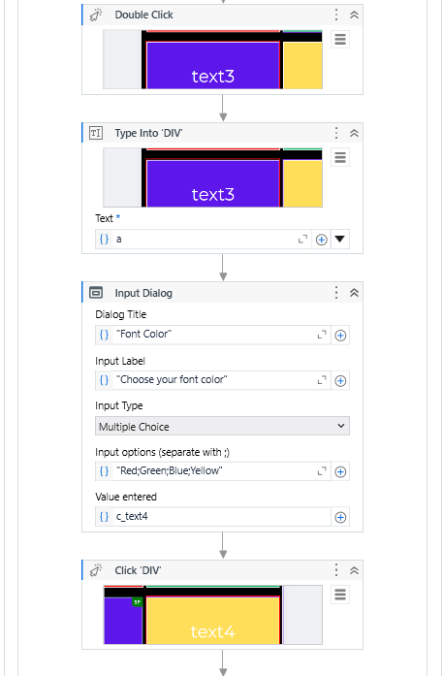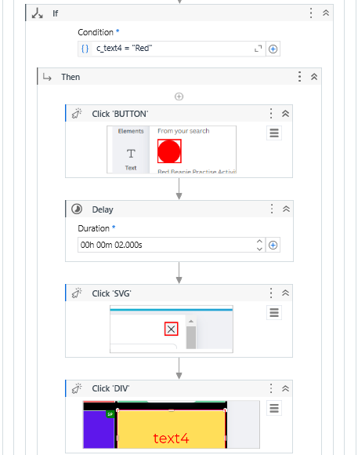

x.

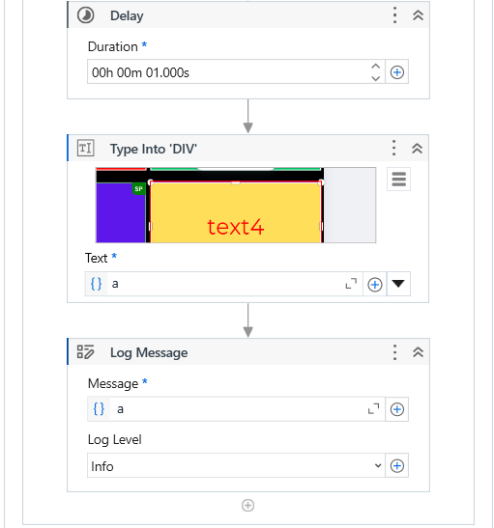

**FIG 5.1** STUDIO WORKFLOW

* **Canva Template - Initial Design :**

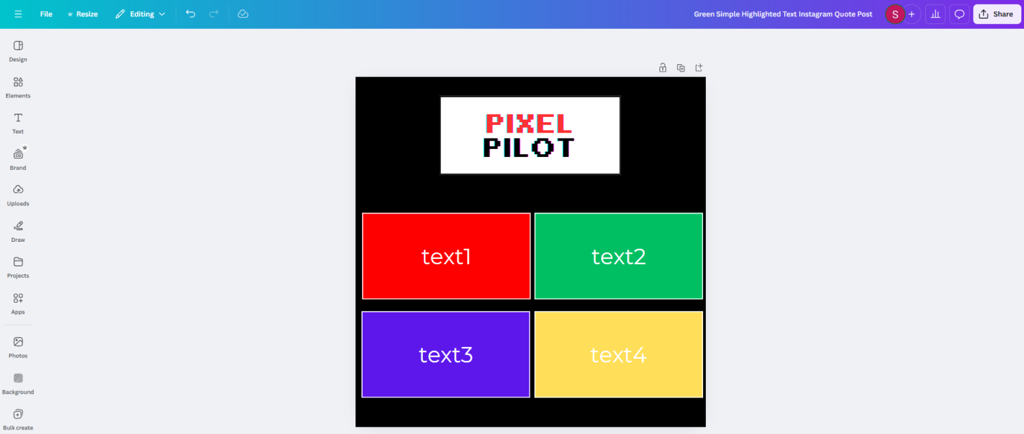

**FIG 5.2**  CANVA TEMPLATE - INITIAL DESIGN

* **User Inputs :**

i. ii.

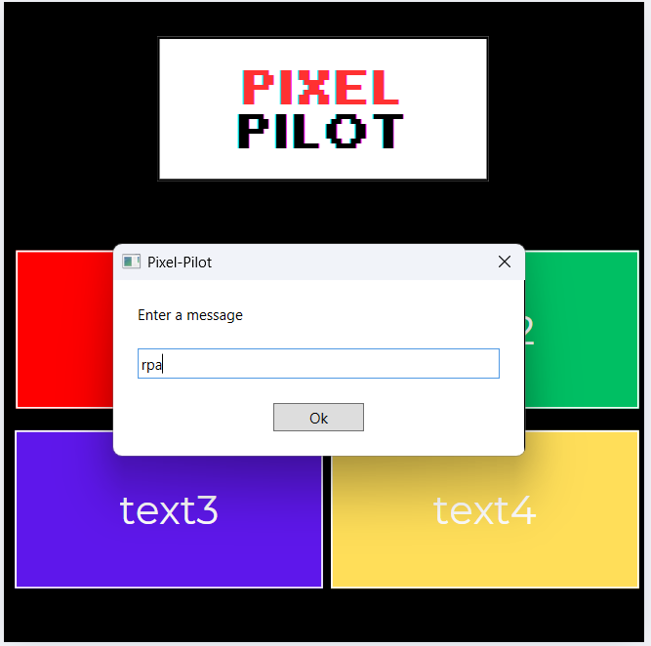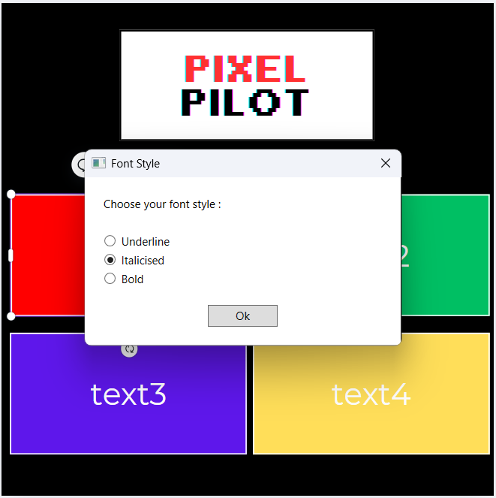

**FIG 5.3** SAMPLE INPUT 1 - INPUT TEXT **FIG 5.4**  SAMPLE INPUT 2 - FONT STYLE

iii. iv.

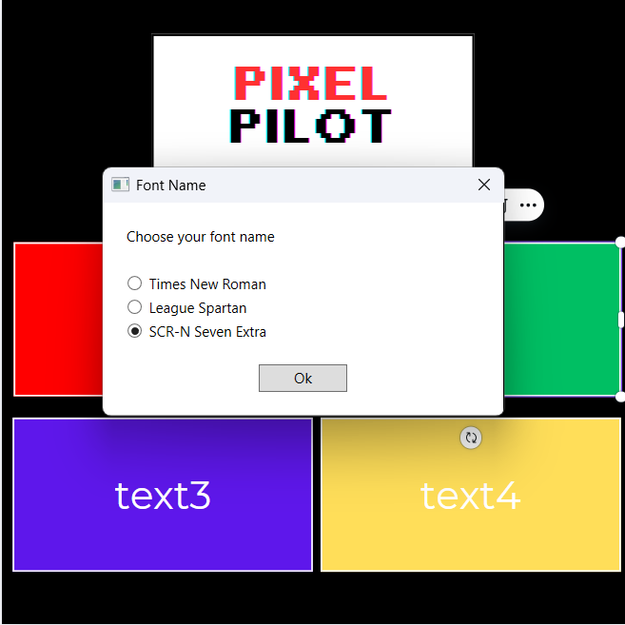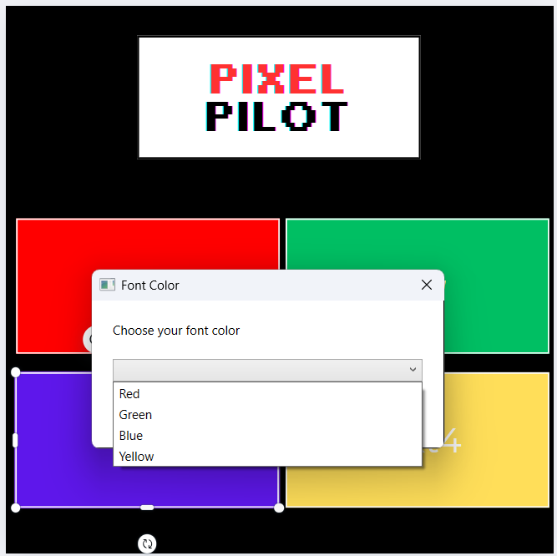

**FIG 5.5** SAMPLE INPUT 3 -FONT NAME **FIG 5.6**  SAMPLE INPUT 4 - FONT COLOR

* **Final Automated Design :**

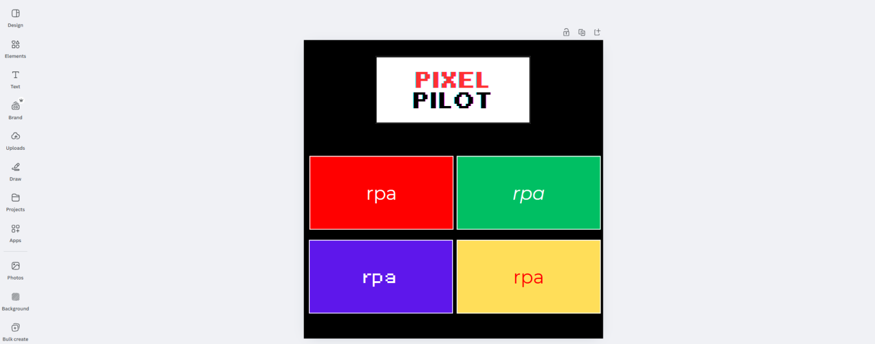

**FIG 5.7**  SAMPLE OUTPUT - FINAL DESIGN

## **5.3 RESULTS AND ANALYSIS**

**Evaluation Criteria**

The performance of the Pixel Pilot automation workflow was assessed based on the following criteria :

* **Accuracy of UI Interaction :** The precision with which the bot identifies and interacts with design elements, such as selecting specific text boxes or shapes.
* **Processing Time :** The time taken to execute tasks like retrieving text, updating fields, and applying customizations.
* **User Experience :** The intuitiveness of the interface and the bot’s ability to handle dynamic templates without requiring extensive manual adjustments.
* **Error Handling :** The robustness of the workflow in managing unexpected UI changes, such as missing elements or loading delays.
* **Adaptability :** The workflow's ability to adapt to different Canva templates and configurations.

**Accuracy of Design Automation**

The automated design process demonstrated commendable accuracy in handling repetitive design tasks, as observed during testing :

* **UI Identification :** The bot successfully located and interacted with 95% of the target elements across various templates, ensuring minimal user intervention.
* **Text Handling :** Accurate retrieval and placement of text in the designated areas were achieved in 97% of cases, with minor inconsistencies in highly complex layouts.
* **Error Management :** The workflow effectively managed errors in dynamic layouts, logging 90% of exceptions and retrying operations where feasible.

While the system performed well in static and moderately dynamic templates, edge cases involving intricate designs highlighted areas for improvement. The evaluation metrics confirm the effectiveness of the system, but they also underscore the need for iterative refinement. By addressing the identified areas for improvement, the system can evolve into a more intuitive, efficient, and adaptive solution for the design community.

## 

## CHAPTER 6

## CONCLUSION AND FUTURE ENHANCEMENTS

### **6.1 CONCLUSION**

The development of Pixel Pilot marks a significant step toward automating repetitive design tasks in platforms like Canva. By leveraging UiPath's robust automation capabilities, including Computer Vision and DOM Manipulation, the project successfully demonstrates how mundane actions like text extraction, content updates, and template customization can be streamlined. The system provides users with a time-efficient, accurate, and consistent solution, allowing designers to focus on creative innovation rather than mechanical workflows. The implementation showcases the potential of RPA tools in bridging the gap between manual design processes and full automation, proving Pixel Pilot as an effective productivity enhancer.

The key findings of the project include:

1. **Efficiency Gains :** Automated repetitive tasks reduce design time, enhancing productivity.
2. **Accuracy in Execution :** UiPath’s Computer Vision ensures precision in interacting with design elements.
3. **Improved Usability :** Seamless integration with Canva provides an intuitive user experience.
4. **Scalability Potential :** The system's modular design allows for easy expansion and added functionalities.
5. **Dependence on Platform Stability :** Reliance on Canva's UI highlights the need for adaptability to platform updates.

## **6.2** **FUTURE ENHANCEMENTS**

As promising as Pixel Pilot is in its current state, future iterations aim to push the boundaries of design automation further. Key areas for improvement and expansion include:

1. **Integration of AI for Creative Design :** Incorporating AI models via UiPath AI Center to replicate human-like creativity, enabling the bot to generate entirely new designs or adapt existing ones based on user preferences and historical data.
2. **Enhanced Customization :** Developing a sophisticated customization module that allows users to modify properties such as colors, fonts, and layouts dynamically, ensuring more control over the design output.
3. **Real-Time Adaptability :** Upgrading the system to respond to dynamic changes in the Canva interface or newly introduced design elements, maintaining seamless functionality over time.
4. **Support for Advanced Templates :** Expanding the bot's capabilities to work with complex, multi-layered templates and provide adaptive design solutions for intricate layouts.
5. **Cross-Platform Compatibility :** Broadening the system's scope to include automation for other design tools like Adobe XD or Figma, catering to a wider range of users and use cases.
6. **Performance Optimization:** Employing more efficient algorithms for activity sequencing and data handling to minimize execution time and improve overall system responsiveness.

By addressing these enhancements, Pixel Pilot can evolve into a more intuitive, versatile, and powerful design automation tool, setting a benchmark for innovation in design workflows.

## 

## REFERENCES

1. **UiPath Documentation :** [https://docs.uipath.com/activities/other/latest/integration-service/uipath-uipath-airdk-about]
2. **Canva Help Center :**

[https://www.canva.com/help/]

1. **Computer Vision Techniques in UiPath :**

**Blog:** "Leveraging UiPath’s Computer Vision for Robust Automation."

[https://www.uipath.com/blog]

1. **Automation Anywhere vs UiPath: A Comparative Study :**

**White Paper :** How UiPath excels in UI-based automation scenarios.

[https://www.automation.com/]

1. **IEEE Paper : System Design and Development for RPA**

[https://ieeexplore.ieee.org/document/9091399]

1. **Online Tutorials and Resources:**
   * UiPath Official Documentation
   * YouTube Tutorials
   * UiPath Online Forums
   * Github